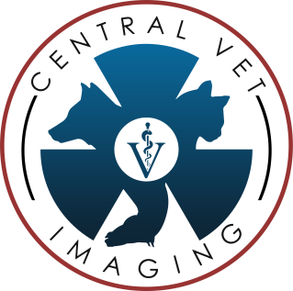
Central Vet Imaging
555 S. 13th Street, Suite D
Grover Beach, CA 93433
Phone: (805) 904-6771 Fax: (805) 904-6772
www.CentralVetImaging.com
email: Staff@centralvetimaging.com

ULTRASOUND REQUEST FORM
Date: _________________
Client Name: ___________________________________________________ Client Phone: ___________________________
Patient Name: _______________________________________ Feline [ ] Canine [ ] Breed: __________________________
Patient Age/DOB: ________________ Patient Sex: M [ ] F [ ] Altered: Y [ ] N [ ] Approximate Wt: ________ lbs
Referral Clinic: _______________________________________ Referral Veterinarian: _______________________________
Pertinent History: _________________________________________________________________________________________________________________
_________________________________________________________________________________________________________________
_________________________________________________________________________________________________________________
_________________________________________________________________________________________________________________
_________________________________________________________________________________________________________________
_________________________________________________________________________________________________________________
_________________________________________________________________________________________________________________
_________________________________________________________________________________________________________________
_________________________________________________________________________________________________________________
** Please send any current pertinent blood work along with the request form. Copies of patient medical records are not necessary.
Are there any radiographs associated with the current condition? Y [ ] N [ ] ________________________________________________
** If yes, please send these images via the Vetology platform to Dr. Jones as a “Non-Billable for Referral” request if you do not want a written interpretation report. If a written interpretation report is desired, please send the images as a standard interpretation request. If you do not use the platform, please send the images via email to staff@centralvetimaging.com, or on a disc with the client if preferred. If you have already submitted the radiographs via the Vetology platform for a reported interpretation, please make a notation on the line above and disregard any resending.
Report Preference: Email [ ] Fax [ ] Phone [ ] (check all that apply) Email: _________________________________________________
This form can be faxed back to Central Vet Imaging at 805-904-6772, or emailed to staff@centralvetimaging.com.

